**Faculty of Science, Engineering and Technology**



**Computer Systems**

***Week 10***

***Part 10.1  
(a) Delay Function***

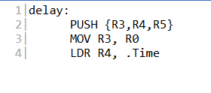

***(b) DrawPixel Function***

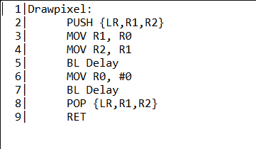

***(c) To make it work***

==> To make the drawpixel function work correctly, you need to save and restore the Link Register (LR). This is because the BL (Branch with Link) instruction used to call the delay function modifies the LR to store the return address. If you don’t save and restore LR, the return address will be lost, and the program won’t return to the correct location after the subroutine call.

***Part 10.2***

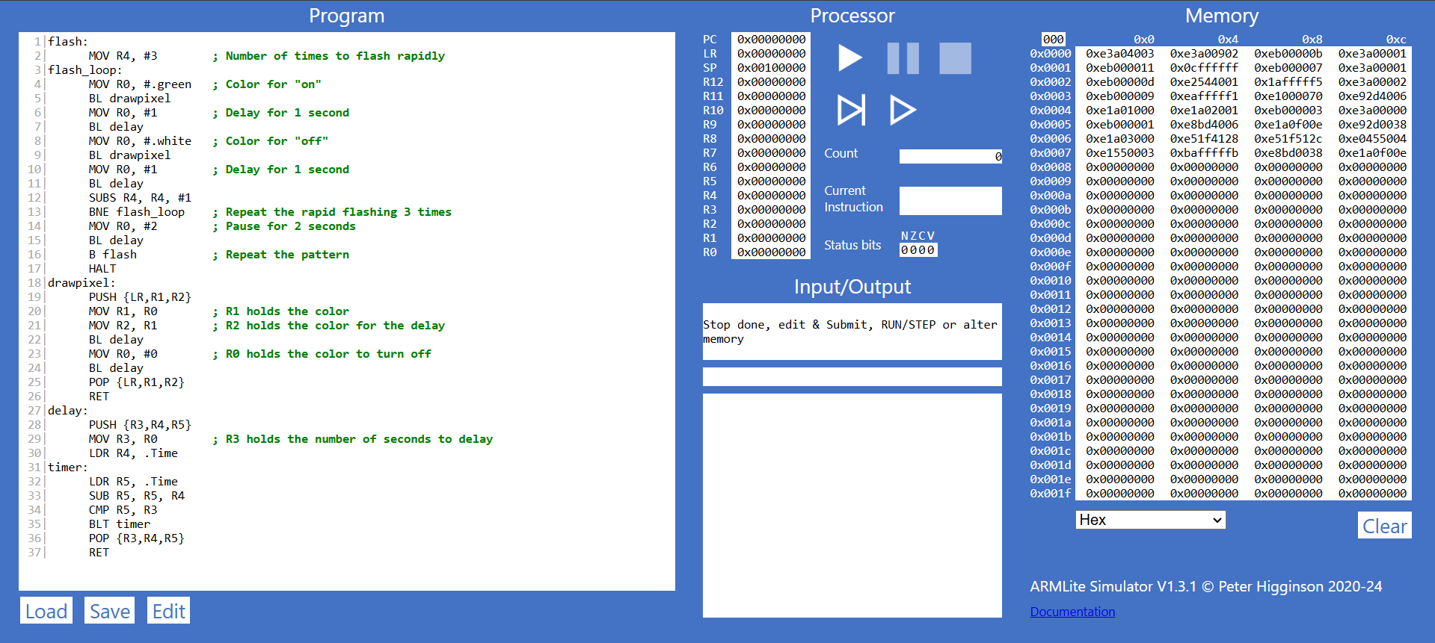

***Part 10.3***

